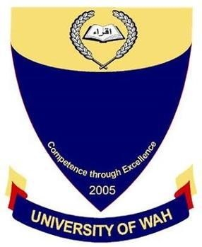
DataBase Lab
UW-24-CS-BS-101
Registration NO:
Muhammad Talha_CS.2ndB
Open Ended Lab
UNIVERSITY OF WAH(UOW)

DEPARTMENT OF COMPUTER
SCIENCE

COURSE:

SUBMITTED TO:

Mr. Afrasiab Sultan
SUBMITTED BY:

Members Table
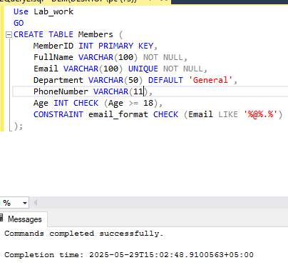
Insert Data
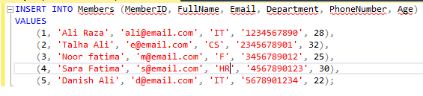
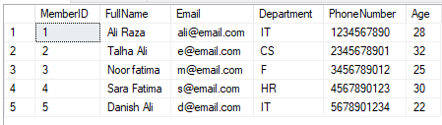

Borrow Table
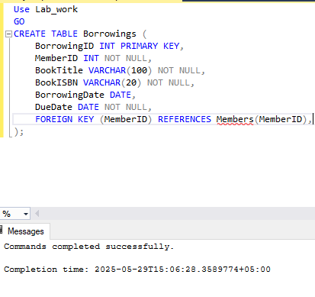

Insert Data
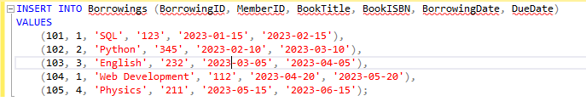
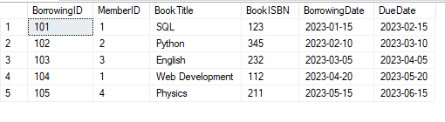
Delete Query
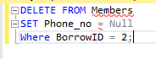

SELECT DATA
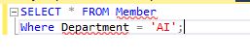

UPDATE QUERY
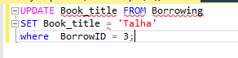
Select in ASC order
